**IT TRUE BLUE**

**Project Management Plan**

**SI Technology Integration**

**Project Team:**

**Aila Macri**

**Alishia Ruff**

**Ananya Sengupta**

**Hao Tran**

**Phillip Bacon**

**TABLE OF CONTENTS**

PROJECT OVERVIEW STATEMENT

BACKGROUND

PROBLEMS & OPPORTUNITIES

GOAL

OBJECTIVES

SUCCESS CRITERIA

Implementation Criteria

Opportunity Criteria

ASSUMPTIONS

RISKS

OBSTACLES

PRODUCT VISION

QUALITY MANAGEMENT

RISK MANAGEMENT

COMMUNICATION MANAGEMENT

ADAPTIVE PLANNING

**Project Overview Statement**

**Background**

Strategic Interventions (SI) is a ten-year-old consulting firm that specializes in strategic consulting, IT consulting, and customizable training programs. SI has grown to have over 300 clients,with 20% growth in both revenue and headcount.

The firm operates under a matrix organization with a board of directors, and a rotating president every three years. SI’s current financial system has proven to be inadequately configured to address the changing needs of the firm and changing ideologies between varying presidents. 

An upgraded system will allow their software to become streamlined across the entire firm. These improvements will provide a way to track expenses, internal billable hours, and increase the accountability of unpaid invoices.

**Problems & Opportunities**

**Problem**: The company is not accurately capturing and collecting revenue; a lack of planning capacity paired with poor reporting is leading to a decrease in billable activities.

**Opportunity**: Adopting a new financial reporting system will allow the company to collect missing revenue and create a strong foundation for future growth, which will ultimately benefit the team and the clients who use the product.

SI’s finance systems were implemented when the company was smaller and did not provide enough support for the entire SI structure. Headcount growth and flattened profits are known problems and will drive the efforts to implement the new financial system.

The data provided did not project costs, profitability, and employee utilization. The company is not billing clients on a rate card as their target is $150/hr, and each account team acts separately on scoping, estimating, contracting consulting agreements with their clients.

There is no current system that supports centralized billing, inconsistent terms, conditions, and collections to manage the company's revenue accurately, and the account leaders are against it. Therefore, account teams are only driving revenue, not profit because there is no cost history.

Bonuses between practice leaders and the company are weighted more heavily on the firm's net profit while each team plans its projects. However, the finance team has been working with a system that served SI’s goal and managed growth well. Using their practice for the other teams to do the similar work for clients will create a good foundation for future projects and capture better profits.

**Goal**

Our goal for this project is to select and implement a new financial system that will modernize current Strategic Interventions’ (SI) financial systems to streamline and optimize processes that manage costs, reporting, and areas of growth by the end of the calendar year.

**Objectives**

* Conduct prioritized business process review to identify business processes that need to be optimized.
* Perform a formal technology selection and project decision with set criteria to determine if FinanceMaster or another vendor meets the needs of SI.
* Derive module requirements based on business process review and definition.
* Implement the first phase of the general ledger and accounts payable modules by the year-end deadline.
* Determine recommended order of implementing the remaining system modules by creating an application implementation roadmap.
* Based on this project, create framework, tools, and methods to capture best practices for future client projects.

**Success Criteria:**

* Creates an automated link between payroll and billing to address any areas of potential
* Decreases company spending and deficits by processing and assigning all expenses through Accounts Payable Identify and reallocates funds to reduce internal non consulting fees
* Generates a detailed cost history to show historic profit
* Tracks cumulative project performance spending to determine utilization rates
* Increases the accuracy and equitability of overall revenue reporting to align with a consistent metric for determining bonuses
* Allows system to set and track billing rates
* Finance charges are set to accrue automatically after 45 days per the firm’s standard client agreements
* Automizes employee expense reimbursement within payroll systems to meet compliance and track employee expenses
* Apart from reducing the operating cost, there is also an opportunity to increase the revenue and thus profit by increasing the consultation utilization by another 6 %.

**Implementation Criteria:**

* Hire at least 5 more people to support new finance system implementation before implementation starts
* Implemented the first phase of the general ledger and accounts payable modules by December 31, 2021.
* Enforce a standardize company-wide contracting and billing with a target of an average billing rate of $150/hour across all billable work
* Standard client agreements must be followed.
* Application implementation roadmap is complete and ready for use by the end of the year.
* Implement centralized billing systems for employees from different practice areas to accurately track annual final financial results ensuring the revenue is invoiced.
* Introduce new modules to be implemented and integrated via API in stages with the General Ledger and Accounts Payable modules.
* Increase utilization of the new system to 75%, or of the 36,800 hours, 27,600 billed to clients.

**Opportunity Criteria:**

* Create and track lessons learned activities and retrospectives throughout the project in a centralized location that is accessible to all consultants.
* A formal project management structure, complete with templates, is created based on the needs of consultants.

**Assumptions**

* Enough resources will be available to implement the new system on time for launch.
* Internal resources have the necessary skills to implement the project.
* Internal resources have adequate time for training on the new system in time for the transition.
* Only GL/AP implementation required by the end of the year.
* Milestones with timelines will not cause delays.
* No significant service disruptions for clients by adopting a new system.
* The company is assuming that all the employees are using the rate card but that may not be the case. This may cause irregular revenue streams from different practice areas.
* If clients fail to pay within 15 days after the bill is raised, they must pay interest, however in practice no finance charges are applied until after 90 days so that charging interest after 45 days makes the clients unhappy and causes business disruption.
* The operating cost of SI is increasing as some account teams don’t bill clients for the expenses submitted to avoid risk of audit.

**Risks**

* For SI each year profit has shrunk as costs have grown faster than revenues.
* The bills are created by the practice administrators, and the amounts billed are manually entered into the financial system as revenue by practice. This can cause an error and incorrect revenue.
* The company has not done a project this large in at least five years, and much of the heavy lifting will be on the finance team. The operating cost of this project can be implemented at least for this fiscal year.
* The timeline is a potential constraint on new system implementation; the installation of the new General Ledger and AP module completed by a year-end so that operations can switch to the new system on January 1st, in sync with the fiscal year.
* The disconnect between financial reporting and practice reporting creates risks with international management and potentially with compliance and auditability of client revenue.
* Workload distribution in the finance team during and after the implementation of the project plan.
* Tight timeline could require additional resources and drive up costs.

**Obstacles**

* The overlapping ownership can be an obstacle because managing quotas and shared revenue is difficult.
* Because of the current lack of accurate and detailed results and performance data, current company planning is done by rough models and comparisons with the final high-level numbers.
* The account leader's bonus potential is heavily based on total gross revenue, all derived from billing. Whereas the bonus potential for the practice leaders is weighted more heavily on the firm’s net profit. Those who are currently benefiting from the system are not excited about changing it.
* Account teams may not be using actual hours worked, potentially missing 2% of annual revenue in additional hours that could have been billed to clients but were misclassified, suggesting utilization could have been higher, at 71%.
* Assigning expenses paid through Accounts Payable to client projects is inconsistent and not enforced in any workflow, causing potentially $2K per client project per year in contracted but unbilled and uncollected client expenses like catering and supplies/printing services.
* Internal non-consulting team costs, including IT Support, Creative Services and Facilities, are not charged to client engagements as costs.
* The firm does not enforce contracting and billing on a rate card, so it will be difficult to determine what

different types of work costs.

**Product Vision**

|  |  |  |  |
| --- | --- | --- | --- |
| **Vision**  *What is your purpose for creating the product?*  *Which possible change should it bring about?* | To improve SI’s overall financial health, a new efficient financial system will be implemented that allows the company to pull data that identifies business growth, financial benefits, and additional revenues.  To attain transparency in a financial reporting process by implementing an efficient tracking mechanism that allows for healthy business growth. | | |
| **Target Group** | **Need** | **Product** | **Business Goal** |
| *Which market or market segment does the product address?*  **There are two products:**   1. Main: New financial system 2. Secondary: Formal project management procedures that internal consultants can use   **Market:**  The product addresses   1. HR processes 2. Expanding internal financial systems & reporting 3. Consultancy business line   *Who are the target customers and users?*  **Internal**  The Finance & Accounting Division will be doing most of the work and implementation.  **External**   * Anyone outside of the Finance & Accounting division.   + See org. Chart  for the rest of the stakeholders. * Current clients * Financial system vendor | *What problem does the product solve?*   1. Correct discrepancy in utilization of billable hours to accurately track revenue to offset the cost 2. Enforce the application of the billable hours 3. Implement standardized application rate for consulting work performed 4. Standardize project management process for future clients   *Which benefit does it provide?*   1. Improve efficiency, productivity, profitability, transparency 2. Achieve overall understanding, commitment, alignment and sponsorship at all levels. 3. Establish a standardized implementation process for future projects      1. Develop more product lines to offer within our consultancy business | *What product is it?*  - A module based financial integration system  *What makes it stand out?*   1. Phase based integration starting with General Ledger and Accounts Payable 2. - Has the ability to be integrated into non FinanceMaster modules in the future to consolidate the company’s internal processes 3. - Meets system criteria as outlined in POS   *Is it feasible to develop the product?*  The current system lacks the ability to meet SI’s growing business. Due to the amount of features needed, the product will be outsourced and integrated into the company in phases. | *How is the product going to benefit the company?*     1. By being able to manage growth efficiently 2. Lesson learned for internal project can be applied to the firm’s product line 3. “Good for us, good for them” 4. Aligning revenue with cost more closely   *What are the business goal/objectives?*   1. To select and implement a new financial system that will modernize current financial systems by December 31. 2. To address misalignment and produce clarity between financial and practice reporting. 3. To streamline and optimize processes that allow for proper allocation of costs, attain transparency in reporting of work performed, generate healthier net profit margins and realize areas of growth by the end of the calendar year. |

**Quality Management Plan**

Strategic Initiatives Quality Management Plan is driven by the integration of a module based system produced by FinanceMaster. These modules are focused on increasing SI’s efficiency in cost estimates, time tracking, and efficiency. The program will be rolled out in phases to improve the General Ledger, Accounts Payable, Purchasing, Budget Planning and Monitoring, Payroll & HR, Accounts Receivable & Billing, as well as Job Costing and Accounting.

**Project Standards**

The project quality standards are required and expected to be upheld by all stakeholder and managed by the PM

**Communication**

Every stakeholder is expected to uphold clear and consistent communication in the style that is outlined in the communication matrix

**Business Process**

Strategic Interventions will collect quantitative and qualitative data to analyze the current financial state of the company and identify areas of growth. An agile focused team will conduct interviews, create a high level workflow, and then connect with subject matter experts to dial in on specific needs.

**Operations**

Expectations and responsibilities will be divided by reviewing areas of expertise and previous performance review metrics to find the strongest members for each role

**Training**

* All stakeholders will be given access to training materials and sessions prior to the module integration
* Training modules and webinars will be accessible online prior to, during, and after the integration

**Technology Standards**

* Strategic Interventions current software will be compatible with the module integration from FinanceMasters.

**Reporting**

* Capture and record qualitative and quantitative data after the initiation of a module integration. Larger reports will be prioritized to keep all parties informed, smaller detailed reports can be requested based upon need but will remain a lower priority.

**Roles and Responsibilities**

|  |  |
| --- | --- |
| **Role** | **Responsibility** |
| **Project Sponsor** | * Approves and signs off on project scope, budget, time allocation, and success criteria * Identifies and addresses issues with staffing concerns, timelines, budgets, quality, and scope * Responsible for meeting deliverables assigned to them * Approves deliverables |
| **Project Manager** | * Overseeing quality of the project * Organizing stakeholders and meeting all stakeholder expectations * Monitoring schedule and budget * Updating reports * Scheduling milestones that meet the desired deliverables * Communicate an Assess the feasibility of requirements and impact of changes * Communicate expectations and needs to all stakeholders |
| **Steering Committee** | Responsible for meeting deliverables assigned to them  Provide guidance in areas of expertise |
| **Subject Matter Experts** | Responsible for meeting deliverables assigned to them  Communicate all quality issues to the PM |

**Project Quality Metrics**

Strategic Initiatives will be following the metrics listed below to ensure that the module integration is successful.

**Training**

* Each employee will have access to training sessions prior to integration. A training performance test will be required after each session. Employees must receive a score of 85% or higher.

**Integration Quality**

* Modules must be testing prior to integration to ensure that all SI employees will have the technological capabilities of accessing the FinanceMasters technology

**Sprint Quality**

* Each sprint must have a 90% success rate

**Project Quality Assurance**

|  |  |  |  |
| --- | --- | --- | --- |
| **Measure** | **Unit** | **Quality Standard** | **Target** |
| Module Testing | Percentage | Testing each module for success prior to go-live. Each module will be tested for bugs, operational accuracy, and technological compatibility | 80% or higher success rate on all tests must be achieved prior to moving onto integration |
| Module Integration | Percentage | Modules will be rolled out and integrated to all applicable staff on the go-live date. | 100% of the staff must have access to the module prior to moving onto utilization reporting |
| Module Utilization | Percentage | Each module’s accessibility, and utilization will be measured after implementation. The module must provide a benefit to enough employees to justify the integration. | 70% or higher utilization rate must be met prior to initiating a new module. If the module hasn’t reached this metric it needs to be reviewed by the PM to address the low utilization score |
| Satisfaction Index | Percentage | Employee satisfaction needs to be recorded | 80% satisfaction or higher must be achieved |
| Change Orders | Weeks | All change orders must be submitted to the PM and must be addressed and resolved. | One week |
| Schedule Variance | Days | All schedule changes must be submitted to the PM | Less than 10% |
| Cost Variance | Dollars | All cost changes must be submitted to the PM | Less than 10% |

**Product Quality Control**

**Training Events and Audits**

All employees will have required training events scheduled prior to a module integration. To ensure that all staff have had ample opportunity to understand the projected changes they will be required to pass a training test prior to go-live.

**Satisfaction Audits**

All employees will be given to opportunity to provide feedback on the integration process and the quality of the modules

**Systems Audits**

All SMEs will evaluate, identify any potential risks, and record any system issues with the PM .

**Risk Management Plan**

Like every other project risk management in SI project is an ongoing activity that will continue throughout the life of the project. This process includes continued activities of risk identification, risk assessment, planning for newly identified risks, monitoring trigger conditions and contingency plans, and risk reporting on a regular basis.

Project team members identified within the stakeholder analysis can raise a risk to the PM team at any time throughout the project. When a risk is raised, the person who raises it enters it in the risk log and PM to analyze the impact, risk probability, and the potential consequences for the project if the risk were to take place.

The PM may also reach out to the team member who raised the risk for more information. Additional research may need to be conducted by either consultants, or subject matter experts to better analyze and understand the impact.

**Steps of the SI Risk Management Process:**

Step 1: Identify the Risk

Step 2: Analyze the Risk

Step 3: Plan Response

Step 4: Monitor and Response

**Risks Categories and Definition:**

|  |  |
| --- | --- |
| **Risk Categories** | **Description** |
| Sponsorship | Any risk that impacts the sponsorship- Since SI has not done a project this large in at least five years, and much of the heavy lifting will be on the finance team, the company’s higher management might be little hesitant about such a big investment. |
| Organization Readiness | Any risk that impacts synchronization and coordination between people, processes, systems and performance measurement - The account leader's bonus potential in SI is heavily based on total gross revenue, all derived from billing. Whereas the bonus potential for the practice leaders is weighted more heavily on the firm’s net profit. Those who are currently benefiting from the system might not be ready for these changes. |
| Modules | Any risk that impacts the implementation of modules - The software doesn't capture all the requirements of SI both internally and externally. |
| Schedule | Any risk that impacts the project timelines - If FinanceMaster fails to implement the software within the calendar year. |
| Cost | Any risk that impacts the overall project cost - If the cost of this software implementation project is beyond the approved budget. |
| Quality | Any risk that impacts the overall quality of project implementation or materials associated - The software implemented by FinanceMaster itself has major bugs, design issues. |
| Insufficient Engineering and User Bandwidth | If FinanceMaster fails to implement the software within the calendar year and lack of resources to do user acceptance testing. |

**Risk Management Roles & Responsibilities:**

The responsibility for managing risk is shared amongst all the stakeholders of the SI project. However, decision authority for selecting whether to proceed with mitigation strategies and implement contingency actions, especially those that have an associated cost or resource requirement rests with the Steering Committee.

|  |  |
| --- | --- |
| **Roles** | **Responsibilities** |
| Project Managers | The PM team is responsible for administering the risk management process |
| Project Sponsors | The project sponsors are responsible for regular communication with the Project Managers to provide direction and support mitigating major issues or concerns |
| SMEs & Team Members | All SMEsand team members are responsible to provide feedback, understand the impacts, and report potential solutions in regards to their tasks. They can raise a risk, participate, and find solutions |

**Risk Prevention & Mitigation Strategies:**

Project Manager and subject matter experts of SI will look at the risks together to see if they relate to each other, review for probability and impact, and prioritize the list of risks that do need response planning. The PM works with the team to identify potential responses and then proposes them to leadership to gain approval for those impacting scope, schedule or cost.A risk log will be maintained to document potential risks and related information and track the risks through the life of the project. The project team will do a weekly analysis and mitigation plan for each risk. This will include developing an approach using our resources and subject matter experts. We will determine if the risk should be accepted, mitigated, avoided, or transferred.

* Avoid/resolve the risk (completely eliminate or forego risk)
* Mitigate the risk (reduce the likelihood or impact of risk)
* Transfer the risk (assign or move the risk to a third-party)
* Enhance the risk (acknowledge the risk and choose not to resolve, transfer or mitigate)

**Risk Severity Matrix:**

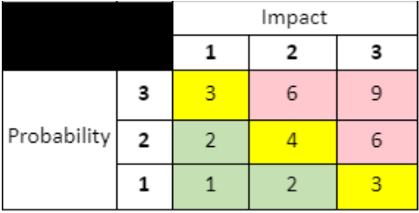

**Risk Probability, Definition and Criteria:**

* All risks will be identified as Green/Yellow/Red using the following criteria:
* Low/Green: Less than 20% chance of occurrence, unlikely or seldom occurrence
* Medium/Yellow: 20 to 50% chance of occurrence, occasionally occurs
* High/Red: Greater than 50% change of occurrence, likely or frequently occurs
* Risks with exposure levels remaining at Yellow or Red state should be elevated and considered
* for further attention/resources.

## Review Schedule, Process, and Parties:

The SI project team will review the risk log on a weekly basis because risk management is an iterative process. Risks will be discussed and analyzed based on the following schedule and control points:

* Weekly sync of the Project Manager with the sponsors.
* Request of weekly status from operating team.
* Daily Sprint check in’s to evaluate % of Sprint completion.
* Status meetings with the Steering Committee as required.
* Weekly check-ins with the IT Team to determine software bugs/issues that may arise.
* Daily check in with the project team lead
* Agile Business Process Team to conduct daily standup meetings and the sprint planning. They will review processes where risks identified through the Business Process work will be addressed at the team level and also reported into the project RAID log.
* Check in with Vendor along with project sponsors to ensure module implementation is agreed and timelines are clear.

**RAID Log Template**:

The risk log is attached below for time to time update of the risks and opportunities throughout the life of the project: [RAID Log - Team True Blue](https://docs.google.com/spreadsheets/u/0/d/1hsh0-cQtvOcjdY08d5VOoLvUyk9NbnIh5-uN9jByyXU/edit)

**Procurement Management**

SI has selected Finance Master as the new financial system so that the procurement management plan will be based on the new technology, project decision with modules implementation and training.

**Procurement Management Roles and Responsibilities**

|  |  |
| --- | --- |
| **Role** | **Responsibility** |
| CEO | Final Decision Approval |
| Co-Executive Sponsor | Support Decision Approval |
| SME | Provide support within expertise areas |
| Legal | Legal Contracting |
| Project Manager | Manage Procurement Management Plan |

**Resources planned for procurement**

|  |  |  |
| --- | --- | --- |
| **Module** | **Vendor** | **Cost** |
| GL/AP | Finance Master | $260k |
| Purchasing | Finance Master | $30k |
| Budget Planning and Monitoring | Finance Master | $30k |
| Payroll/HR | Finance Master | $65k |
| Extended Account Receivable/Billing | Finance Master | $65k |
| Job Costing/Project Accounting | Finance Master | $65k |

**Resources are assigned working full time with fixed duration**

|  |  |  |
| --- | --- | --- |
| **Team/Member** | **Availability** | **Source** |
| Finance Master team | Track progress, training and manage handoffs | External |
| 1 Project Manager | 50% | Internal |
| 1 Business Analyst | Full time | Internal |
| 1 Data Analyst | 50% | Internal |
| 1 Test Analyst | 50% | Internal |

**Procurement Analysis**

This Procurement Management Plan will be the foundation for the implementation process to meet all the checkpoints for our quality purposes.

1. **Requirement for implementation process**

Vendor must meet specific criteria quality deliverables based on the implementation modules process:

* GL/AP
* Purchasing
* Budget Planning and Monitoring
* Payroll/HR
* Extended Accounts
* Receivable/Billing
* Job Costing/Project Accounting

1. **Acquisition Process**

* Vendor needs to get approvals for each agile review process by the end of each sprint from the executive team.
* Module testing approach meet every checkpoint in the process including:

-Module in development environment

-Module in test environment

-Module in production environment

-Module in stabilization

* **Meet sponsor assumptions:**

-Minimal data conversion, except for opening balances and in-process

-Client engagement data retained in current format. The team will build up new projects in the new system as they start.

-Finance Master has built in reporting and a query tool.

-Running one module at a time, no need to buy and configure everything to go live over time.

* Decisions from executive sponsors to move forward before going live and exiting stabilization to start the next module.

**Score**

* All ratings will be on the scale of 1-3, all whole numbers.

**Definition of Criteria:**

**Cost:** cost for business case purpose, ongoing FinanceMaster maintenance and support license should meet at $130k/year as planned, not including out of scope.

**Quality:** implementation of each module meets executive sponsors’ requirements, able to manage change management quickly and resolve issues.

**Schedule:** deliver each module simultaneously, to go live by year end for use starting Jan 1.

**User Experience:** new system is complying and working efficiently.

**Evaluation Supplier Matrix**

|  |  |  |  |  |  |  |  |
| --- | --- | --- | --- | --- | --- | --- | --- |
|  | | **Vendor 1** | | **Vendor 2** | | **Vendor 3** | |
| Criteria | Weight | Rating | Score | Rating | Score | Rating | Score |
| Cost | 30% | 3 | 0.9 | 1 | 0.3 | 2 | 0.6 |
| Quality | 40% | 2 | 0.8 | 1 | 0.4 | 1 | 0.4 |
| Schedule | 20% | 2 | 0.4 | 3 | 0.6 | 1 | 0.2 |
| User Experience | 10% | 2 | 0.2 | 2 | 0.2 | 2 | 0.2 |
| Total Score | 100% |  | 2.3 |  | 1.5 |  | 1.4 |

**Procurement Activities**

1. Plan Procurement: based on the statement of work, the project manager will gather information and needs from executive sponsor, SMEs, on business process

2. Conduct Procurement: the project manager will work with SI’s leadership team to comment on the importance of having our requirements identified before beginning an RFP/Q process culminating in demonstrations by the vendors to support a criteria-based decision.

3. Control Procurement: the team will be working closely with vendors on time, budgets, and schedules. Project manager will communicate and keep all the sponsors, SME up to date with any changes and project status.

4. Close Procurement: the project manager and the vendor will close out the contract.

**Communication**

**Communication Process:**

The following [Communication Management Plan](https://docs.google.com/spreadsheets/d/1Qydsbp5ejSM75ZT9S7D1hvhk8UryUzK2wp3_-L4yyaU/edit?usp=sharing) is used to keep track of major communication events that will happen for the duration of the project. The plan is managed by the PMs and reviewed with the PM Team. Additions and revisions requests can be submitted by any team member and emailed to PMs ahead of time for review. The request will be reviewed and updated into the communication matrix by the lead PM following final written approval from the drive/requestor.

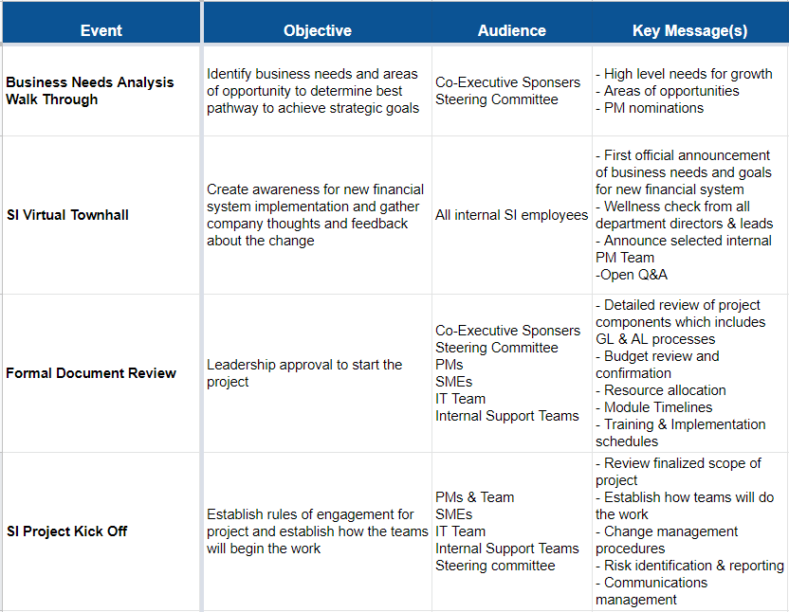

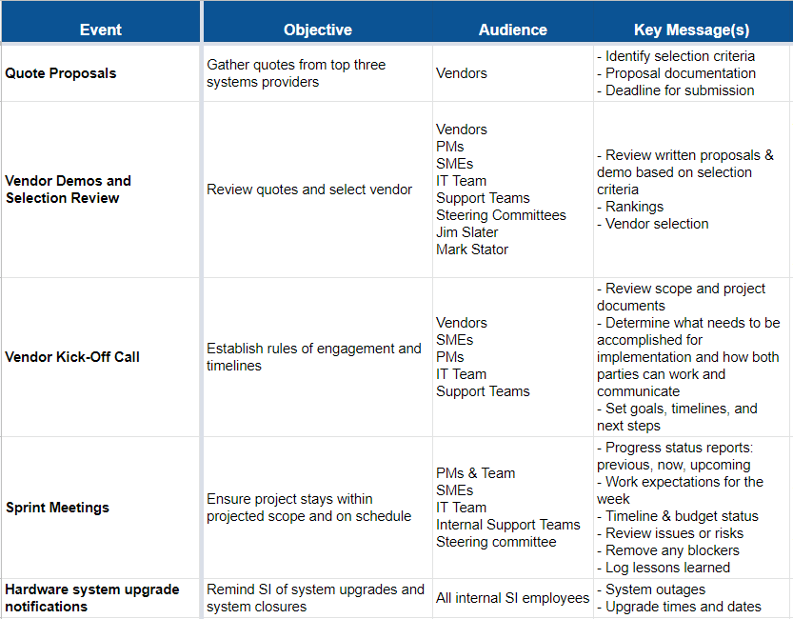

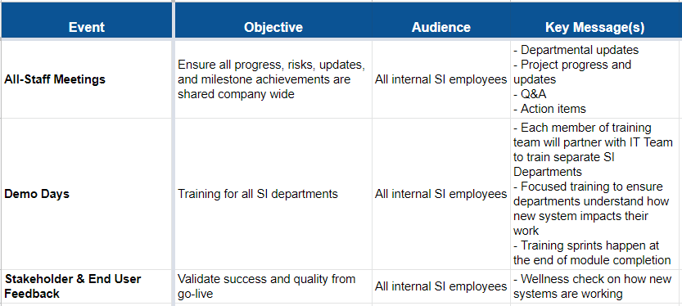

**Adaptive Planning**

**Change Control**

Project change control roles and responsibilities:

|  |  |
| --- | --- |
| **Role** | **Responsibility** |
| Executive Sponsors | Final Approve/Reject all requests after review |
| Steering Committee | Review to provide guidance, determine risks and opportunities based on the changes to maximize the project needs. Approve/Reject requests |
| SMEs | Giving advice within their knowledge area. Support change requests |
| Project Manager | Manage change management plan. Create and build change request log, template, change process. Deliver change requests with timely fashion to upper level management schedule and needs. |
| IT Team | Accept and update changes with approvals |
| Finance Master | Coordinate and review all approved changes with  The project manager to ensure that they approve all change  requests and can implement the changes. |

Process for change request submission, analysis, approval and implementation:

**Change request submittal:**

1. All change requests must be filled out and follow the change request template, then submit it to the project manager via Sharepoint.
2. Latest to submit for change requests every week will be on Wednesday at 11:59pm to get submitted to the Change Control Board.

**Reviewing change request:**

1. The project manager will review change requests, navigate changes by asking questions and go over the request with requesters to get ready to submit it to the Change Control Board. Any change requests that are not able to clarify or need more information will have time to do so the next day.
2. All change requests submitted to the Change Control Board will be logged in the change control log in Sharepoint.
3. The Change Control Board will review the requests on Friday and make a final decision on Monday next week

**Final Approval and Denial:**

1. All change requests must be considered to meet project scope, budget and schedule before final approval for implementation.
2. Final rejected/approved change requests will also be logged in log change control.
3. Final approved change requests get a green light to move on to implementation. Project manager will communicate with all the stakeholders who are involved in the change process.
4. Any rejected requests will need to reevaluate before resubmit for the following week.

**Change request form template**

|  |  |  |
| --- | --- | --- |
| **Change ID** | **Requestor** | **Date** |
| **Change Category (check all apply):**   |  |  |  |  |  | | --- | --- | --- | --- | --- | | **Schedule** | **Cost** | **Scope** | **Testing/Quality** | **Requirement/Deliverables** | | | |
| **Reason for Change:** | | |
| **Description of Change:** | | |
| **Status :**   |  |  |  | | --- | --- | --- | | **In Review** | **Approved** | **Rejected** | | | |
| **Notes from Status:** | | |
| **Approval Date:** | **Signature:** | |

**Change request log template**

|  |  |  |  |  |  |  |  |  |
| --- | --- | --- | --- | --- | --- | --- | --- | --- |
| **Change Request Log Template** | | | | | | | | |
| **Change ID** | **Description** | **PM** | **Requestor** | **Date Submitted** | **Last update** | **Approved/Rejected** | **Decision by** | **Revisit**  **(Y/N)** |
|  |  |  |  |  |  |  |  |  |
|  |  |  |  |  |  |  |  |  |
|  |  |  |  |  |  |  |  |  |
|  |  |  |  |  |  |  |  |  |

**Adaptive Change**

Finance Master will implement the first modules phase Gl/AP, then go live by January 1. GL/AP are the foundation to set for the implementation process in this project so that any changes at this time are very important to review and resolve. Here is how changes will be performed in the adaptive work cycles:

|  |  |
| --- | --- |
| **Submit Change Requests** | On Wednesday via Sharepoint |
| **Weekly meeting review** | On Friday, the change control board will meet to go over all the change requests to make decisions for final approvals on Monday. |
| **Approval and Denial** | Final decisions will be made on Monday  Project manager will update change request status on Sharepoint.  **Approved:**  The PM will follow up with the requesters to revise the work that followed with all the new changes.  **Rejected:**  The PM will communicate with the requesters with comments on the rejection and maybe new submission |